Improved Diabetes Prediction Accuracy Using Hybrid Machine Learning Models
____________________________________


by
Qasim Zafar
2024(S)-MS-DS-05
Research Supervisor:
Dr. Junaid Arshad
2026
_______________________________________
Institute of Data Science
University of Engineering and Technology, Lahore
IMPROVED DIABETE PREDICTION ACCURACY USING HYBRID MACHINE LEARNING MODELS

by
Qasim Zafar

A THESIS
presented to the university of engineering and technology, Lahore
in partial fulfillment of the requirements for the degree of
Master of Science
in
Data Science
APPROVED BY:

[Primary Advisor/Internal Examiner] [External Examiner]
[Official Title & Department] [Official Title & Department]

[Chairman of the Department] [Dean of Faculty]

[Publish Date]

INSTITUTE OF DATA SCIENCE
UNIVERSITY OF ENGINEERING & TECHNOLOGY, LAHORE

© 2026
Qasim Zafar
All Rights Reserved
Any part of this thesis cannot be copied, reproduced or published without the written approval of the Scholar.

ABSTRACT
Diabetes mellitus (DM), a metabolic disorder, becomes epidemic and affects millions of individuals in whole world, its early detection is important to prevent debilitating complications for better patient management. Diagnosis of diabetes based on the prediction systems which will be developed using machine learning are promising, but research indicates that a medical dataset can frequently contain missing values or outliers and is inadequately pre-processed. To overcome these limitations, this study puts forward a new hybrid stacking ensemble framework for reliable diabetes prediction applying extensive preprocessing and advanced ensembled learning techniques. The methodology utilizes the PIMA Indian Diabetes dataset which consist 768 female patients (268 Diabetic, and 500 No-Diabetic) A robust multi-stage preprocessing pipeline is applied: (i) group median imputation to handle missing values, (ii) IQR-based outlier detection and replaced with median, (iii) max-min normalization to scale features to the range of 0 to 1, (iv) interaction feature engineering to learn complex interactions among variables. To be classified, a hybrid stacking ensemble model is created, where five different base classifiers are employed: Random Forest (RF), XGBoost, LightGBM, AdaBoost, and Decision Tree (DT) and Logistic Regression (LR) are used as the meta-learner. To be robust and able to generalize, the model is assessed with the help of 10-fold stratified cross-validation. The experimental findings indicate that the hybrid stacking ensemble proposed has excellent performance with an accuracy of 94.74, sensitivity of 91.67, specificity of 96.15, precision of 91.67, AUC of 0.9833 and F1-score of 91.67. These performances are very good compared to the current methods. The suggested hybrid stacking ensemble model constitutes a valid and precise tool of early diabetes risk stratification with the possibility of becoming a part of clinical decision support systems. Further research will be done to test the model on various data sets, investigate other feature selection methods and create a web based application that can be easily used in the real healthcare environment.

ACKNOWLEDGMENTS
I want to thank my supervisor Associate Prof. Dr. M Junaid Arshad for the excellent supervision and guidance. I want to thank the Institute of Data Science at UET Lahore including professors, seniors, and batch mates for supporting this research.

STATEMENT OF ORGINALITY
I, Qasim Zafar, hereby declare that the work presented in this thesis titled "Improved Diabetes Prediction Accuracy Using Hybrid Machine Learning Models" is my own original research. I confirm that:
This work has not been submitted previously for any degree or qualification at this or any other university.
All sources of information, including figures, tables, and text, have been appropriately cited and referenced.
The contributions of other researchers have been acknowledged properly.
All experimental results presented are genuine and have not been fabricated or manipulated.

Date: _______________
Signature: _______________
Qasim Zafar
2024(S)-MS-DS-05
Department of Data Science
UET, Lahore

TABLE OF CONTENTS
ABSTRACT ……………………………………………………………………….. 5
ACKNOWLEDGMENTS ………………………………………………….………7
STATEMENT OF ORIGINALITY ………………………………………..…….. 8
TABLE OF CONTENTS ……………………………………………………..…… 9
LIST OF FIGURES ……………………………………………………..………... 12
LIST OF TABLES ……………………………………………………………..…..13
NOMENCLATURE ………………………….……………………….….…...……14
1. INTRODUCTION ………………………………………………….……..……..15
1.1 Background of Diabetes Mellitus ……………………………….….….…….15
1.2 Problem Statement ……………………………………………….…………..17
1.3 Motivation …………………………………………………………………….18
2. LITERATURE REVIEW ……………………………………………………….20
2.1 Machine Learning in Healthcare ……………………………………………20
2.2 Existing Diabetes Prediction Studies ………………………………………..22
2.3 Research Gaps ………………………………………………………………..24
3. RESEARCH METHODOLOGY ………………………………………………26
3.1 Dataset Description (PIMA Indian Dataset) ……………………………….26
3.2 Preprocessing Pipeline …………………………………………………….…28
3.2.1 Missing Value Imputation using Group Median ……………………...28
3.2.2 Outlier Detection and Treatment using IQR …………………………..30
3.2.3 Max-Min Normalization ………………………………………………...33
3.2.4 Feature Engineering (Interaction Features) …………………………...35
3.3 Feature Selection using Random Forest ……………………………….……39
3.4 Hybrid Stacking Ensemble Model …………………………………………..40
3.4.1 Base Classifiers …………………………………………………………..42
3.4.2 Meta-Learner …………………………………………………………….43
3.5 Evaluation Metrics & Cross-Validation …………………………………….44
3.5.1 Confusion Metrics & Fundamentals……………………………………44
3.5.2 Evaluation Metrics……………………………………………………….45
3.5.3 10-Fold Stratified Cross-Validation…………………………………….48
3.5.4 Mathematical Summary of Evaluation Protocol……………………….51
4. RESULTS AND DISCUSSION ……………………………………………….. 53
4.1 Experimental Results ……………………………………………………….. 53
4.2 Comparison with Existing Methods ……………………………………….. 57
4.3 Reliability & Stability Analysis …………………………………………….. 60
5. CONCLUSION AND FUTURE WORK ……………………………………… 63
5.1 Summary of Key Findings ………………………………………………….. 63
5.2 Contributions of the Research ………………………………………………64
5.3 Limitations ……………………………………………………………………65
5.4 Future Work Recommendations ……………………………………………66
6. BIBLIOGRAPHY ……………………………………………………………….68
7. APPENDICES ……………………………………………………………….…..70
Appendix A: Dataset Description ……………………………………………. 54
Appendix B: Additional Results ………………………………….……..…… 58
8. VITAE ……………………………………………………………………………71

LIST OF FIGURES
Figure 1.1 Prevalence of Diabetes Worldwide (IDF 2021)……………………….15
Figure 1.2 Complications Associated with Uncontrolled Diabetes………………16
Figure 3.1 Before and After Missing Value Replacement by Median…………...30
Figure 3.2 Before and After Outlier Removal by IQR………….…..……………32
Figure 3.3 Max-Min Normalization: Feature Scaling to [0,1] Range……………35
Figure 3.4 Interaction Feature Engineering Visualization……………………….38
Figure 3.5 Flowchart of Data Preparation Pipeline………………………………39
Figure 3.6 Random Forest Feature Importance Scores (Top 15 Features)……..40
Figure 3.7 Architecture of Hybrid Stacking Ensemble Model…………………..41
Figure 4.1 ROC Curves of Hybrid Stacking Models……………………………..55
Figure 4.2 Confusion Matrix of Proposed Hybrid Stacking Ensemble…………56
Figure 4.3 Correlation Matrix of Base Classifiers………………………………..57
Figure 4.4 Performance Comparison Bar Chart…………………………………59

LIST OF TABLES
Table 1.1 Demographics of PIMA Indian Diabetes Dataset ………………….…17
Table 2.1 Summary of Existing Diabetes Prediction Studies ……………………23
Table 3.1 Attribute Description of PIMA Dataset ………………………………..27
Table 3.2 Statistical Summary of Dataset Features ……………………………...27
Table 4.1 Performance Comparison: Experiment 1 vs Experiment 2 ………….53
Table 4.2 Detailed Performance Metrics of Proposed Model …………………...54
Table 4.3 Meta-Model Weights (Logistic Regression Coefficients) …………..…57
Table 4.4 Comparison with State-of-the-Art Methods ……………………….….58
Table 4.5 10-Fold Cross-Validation Stability Results ………………………..…..62

NOMENCLATURE
Symbol Description
ACC Accuracy
AdaBoost Adaptive Boosting
ANN Artificial Neural Network
AUC Area Under the ROC Curve
BMI Body Mass Index
CNN Convolutional Neural Network
CV Cross-Validation
DM Diabetes Mellitus
DT Decision Tree
F1 F1-Score (Harmonic mean of Precision and Recall)
FN False Negative
FP False Positive
GBC Gradient Boosting Classifier
IQR Inter-Quartile Range
KNN K-Nearest Neighbors
LDA Linear Discriminant Analysis
LightGBM Light Gradient Boosting Machine
LR Logistic Regression
ML Machine Learning

Introduction

Background of Diabetes Mellitus
Diabetes mellitus is a chronic metabolic condition which is associated with high blood glucose levels caused by insulin secretion defects insulin action defects or both [1]. The International diabetes Federation estimate that there were 537 million adults 20-79 years with diabetes in 2021 and estimates that by 2045 [2] the number will have increased to 73 million Figure 1.1. A major cause of blindness , kidney failure, heart attack and amputation [3] of lower limbs are diabetes Figure 1.2.
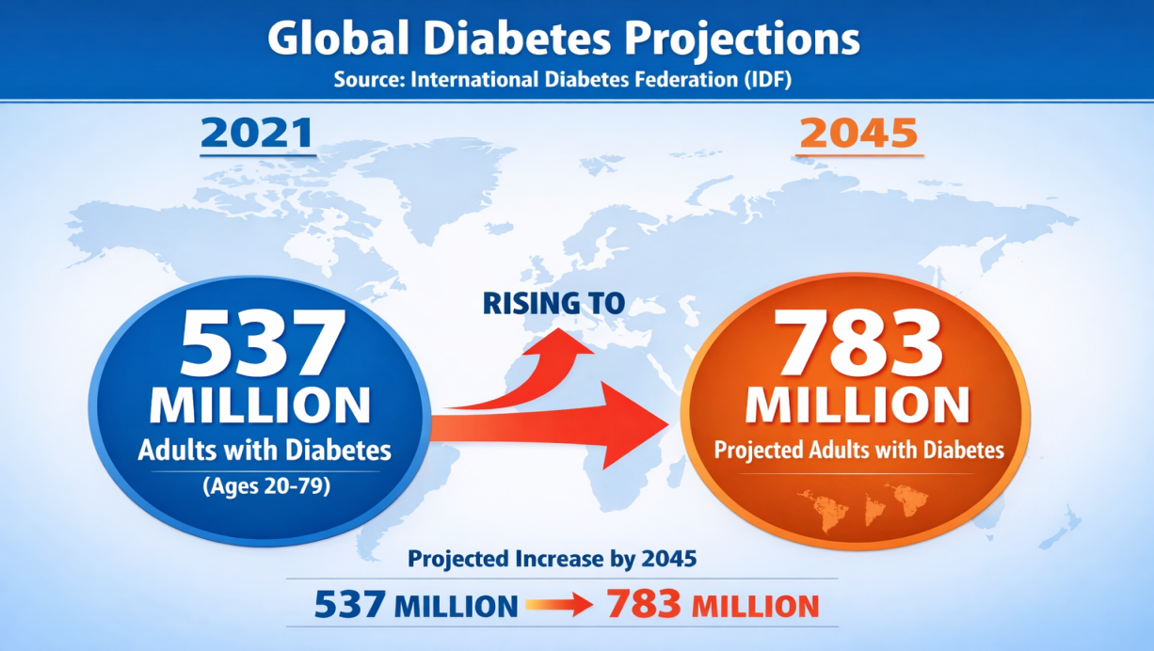
Figure 1.1 Prevalence of Diabetes Worlld wide(IDF2021).

There are three main types of diabetes:
- Type 1 Diabetes: Pancreatic 8 cells are destroyed by autoimmune means resulting in complete insulin deficiency.
- Diabetes type 2 is when the body gets insulin but does not use it well. The insulin also does not get into the cells easily. This is called insulin resistance.
- Gestational Diabetes is when women get diabetes during pregnancy. This is a deal for women who are pregnant.
Early diagnosis and treatment of Diabetes are very important. Gestational Diabetes needs to be found and treated early. This helps prevent problems for women with Diabetes and improves the outcomes for women, with Gestational Diabetes. Machine learning is a tool. It looks at information to find patterns. These patterns help doctors figure out who is at risk, for diabetes. Doctors use this information to assess the risk [1,2] Machine learning helps with diabetes risk assessment. It is good at finding diabetes risk. Doctors use machine learning, for diabetes.
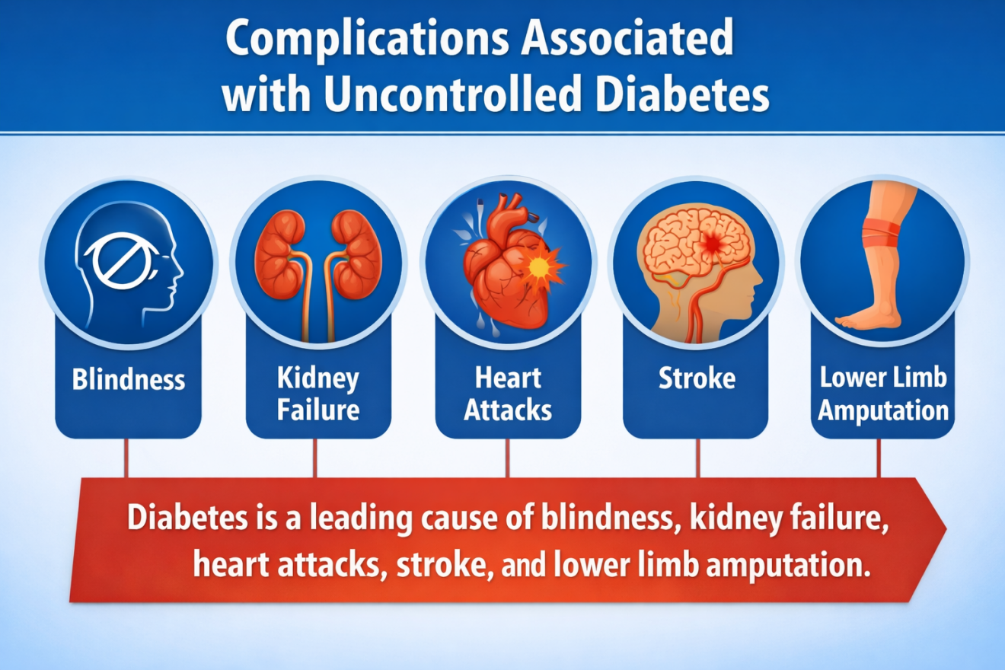

Figure 1.2 Complications Associated with Uncontrolled Diabetes.

The PIMA Indian Diabetes Dataset (PIDD) has been a standard of diabetes prediction studies [6]. This is a data set of 768 female patients (of Pima Indian ancestry) of age 21 years or older of which 268 were diabetic (34.9%) and 500 were non-diabetic (65.1%) [1,2]. Table 1.1 shows that the dataset has eight clinical attributes.

Attribute | Description | Mean ± SD
Pregnancies | Number of times pregnant | 4.38 ± 3.01
Glucose | Plasma glucose concentration (mg/dL) | 121.67 ± 30.46
BloodPressure | Diastolic blood pressure (mm Hg) | 72.38 ± 12.10
SkinThickness | Triceps skin fold thickness (mm) | 29.08 ± 8.89
Insulin | 2-Hour serum insulin (μU/mL) | 141.76 ± 89.10
BMI | Body mass index (kg/m²) | 32.43 ± 6.88
DiabetesPedigreeFunction | Diabetes pedigree function | 0.47 ± 0.33
Age | Age in years | 33.24 ± 11.76

Table 1.1: Demographics of PIMA Indian Diabetes Dataset.

Problem Statement
Even with the considerable improvement in machine learning-based diabetes prediction systems, a number of severe limitations remain that impede the process of creating models that can be used in clinical settings [1]. Medical data, such as the PIMA Indian Diabetes Dataset (PIDD), has many zero values which, in clinical terms, are impossible (e.g., zero glucose, zero BMI, zero blood pressure), and which are typically treated poorly or not at all in the literature, resulting in biased predictions and lower model predictability [2]. Also, extreme points in clinical data can severely bias model training by moving statistical statistics and making algorithms to fit to the outliers instead of the underlying trends, but much of current practice is unable or imperfect at identifying or dealing with these outliers [2,5]. Moreover, a lot of literature does not have appropriate preprocessing methods such as normalization (which makes all features equally important) and feature engineering (which serves to represent non-linear relationships between the variables that are complex), which means that the models perform poorly [1,4,6]. The other serious constraint is the absence of diversity in the classifiers since prior ensemble methods apply only 2-3 classifiers [4,8,11] that restrict the model capacity to find a wide variety of patterns in the data and raises the bias and variance. Lastly, the issue of generalization remains since most models are tested with easy train-test splits without sound cross-validation, which casts significant doubts on overfitting and the capacity of the model to make consistent predictions on unknown data. The proposed research will fill these seven gaps with a multifaceted hybrid stacking ensemble system that has strong preprocessing, a wide range of base classifiers, and stringent validation procedures.

Motivation
This study was inspired by four main observations which together point to the fact that there is a dire need to develop better diabetes prediction systems. First, the clinical impact First, early and accurate diagnosis of diabetes can avert life threatening complications such as cardiovascular disease, kidney failure, and retinopathy, save healthcare expenditures and increase the life quality of millions of patients worldwide [1,3,5]. Second, a systematic research gap review of literature shows that only 4/12 studies performed imputation of missing values, only 3/12 studies dealt with outliers, only 2/12 studies applied feature engineering techniques, and the majority of ensemble techniques applied were only 2-3 classifiers, which shows that current methods are utterly limited. Third, the latest developments in ensemble learning, especially stacking ensembles, which are aggregations of many classifiers, using a meta-learner, provide unprecedented technological possibilities to obtain a high level of prediction using the synergies of different algorithms [8,14]. Fourth, a highly predictive, consistent, and dependable model of diabetes prediction can be easily implemented into clinical decision support systems and electronic health records to allow healthcare professionals to detect at-risk patients and provide them with early intervention and timely treatment. It is against this background, based on these observations that this study will fill the identified gaps by proposing a new hybrid stacking ensemble framework that includes extensive preprocessing (group median imputation, IQR-based outlier removal, max-min normalization, and interaction feature engineering), five different base classifiers (Random Forest, XGBoost, LightGBM, AdaBoost and Decision Tree) with Logistic Regression as meta- learner [2,12].

Literature Review

Machine Learning in Healthcare
The field of healthcare analytics has changed a lot because of machine learning. Now we can make models that can predict when someone will get a disease how the disease will progress and what the best treatment will be [1,2]. We can break down how machine learning is used in healthcare into an areas [3].

Disease Prediction and Diagnosis:
Machine learning looks at a lot of information about patients like what doctor they go to, where they live and what genes they have. Then it tries to figure out if they will get a disease. For example machine learning can help us predict if someone will get diabetes, heart disease, cancer or kidney disease [1,2,5,14].
Medical Image Analysis:
Some machine learning models, like Convolutional Neural Networks are really good at looking at pictures of the inside of our bodies like X-rays and MRIs. They can even find problems that a doctor might miss [6,9].
Electronic Health Records Analytics:
Machine learning helps us understand what is in a patients health records. They can even spot problems that a doctor might not catch.
Electronic Health Records Analytics:
Machine learning helps us make sense of whats in a patients health records. This info can help doctors see who might get sick and how they can help them. Doctors can use this info to help patients get better. Machine learning also helps doctors decide on the treatment, for their patients [7,15,16].

Key ML Algorithms Used in Healthcare:

Algorithm | Type | Strengths | Limitations
Logistic Regression | Linear | Interpretable, fast | Assumes linearity
Decision Tree | Tree-based | Easy to interpret | Prone to overfitting
Random Forest | Ensemble (Bagging) | Handles non-linearity, robust | Less interpretable
SVM | Kernel-based | Effective in high dimensions | Slow for large datasets
XGBoost | Ensemble (Boosting) | High accuracy, handles missing data | Many hyperparameters
Neural Networks | Deep Learning | Captures complex patterns | Requires large data, black box
AdaBoost | Ensemble (Boosting) | Simple to implement, works well with weak learners | Sensitive to noisy data and outliers, slower than Gradient Boosting on large datasets
LightGBM | Ensemble (Boosting) | Faster than XGBoost lower memory usage, handles large datasets efficiently | Can overfit on small datasets (<10,000 samples), leaf-wise growth can create unbalanced trees

Existing Diabetes Prediction Studies
Much literature has been done on predicting diabetes through the PIMA dataset by using ML models. The following table 2.1 gives a detailed overview of literature.

SN | Author(s) | Year | Preprocessing | Feature Selection | Model | Accuracy
1 | Sisodia & Sisodia | 2018 | None | None | Naive Bayes | 76.30%
2 | Maniruzzaman et al. | 2018 | Group median (MV), IQR (outliers) | RF, PCA, MI, ANOVA | RF + RF-FS | 92.26%
3 | Battineni et al. | 2019 | None | None | Logistic Regression | 77.00%
4 | Kumari et al. | 2021 | Median imputation | None | Soft Voting Ensemble | 79.04%
5 | Khanam & Foo | 2021 | Mean imputation, outlier removal | Pearson's correlation | Neural Network | 88.60%
6 | Garcia-Ordás et al. | 2021 | Mean imputation | SAE (feature augmentation) | CNN + SAE | 92.31%
7 | Krishnamoorthi et al. | 2022 | Yes (unspecified) | None | Logistic Regression | 83.00%
8 | Alzubaidi et al. | 2023 | Mean/Median | None | Stacking (RF+LR→XGB) | 83.00%
9 | Al-Zu'bi et al. | 2023 | None | None | Deep Learning (MLP) | 80.00%
10 | Al-Asadi et al. | 2024 | Yes | None | Hybrid (SVM+DT+RF) | 90.10%
11 | Kalavani et al. | 2025 | Yes | None | Hybrid (DT+GBC) | 92.00%
12 | Proposed Method | - | Group median + IQR + Norm + FE | Random Forest | Stacking (5 base + LR meta) | 94.74%

Table 2.1: Summary of Existing Diabetes Prediction Studies

Critical Analysis of Existing Studies:
Naive Bayes, SVM and Decision tree were utilized by Sisodia and Sisodia [1] with no accuracies recorded because they were not preprocessed.

With group median imputation, IQR-based outlier removal and RF feature selection with RF classification, Maniruzzaman et al. [2] obtained 92.26% accuracy, the current state-of-the-art.n. They did not however use normalization or feature engineering.
After mean imputation, outlier removal, and correlation-based feature selection, Khanam and Foo [5] applied neural networks with two hidden layers that attained 88.6% accuracy.
Garcia-Ordas et al. [6] obtained 92.31% accuracy with deep learning with VAE oversampling and SAE feature augmentation, although this method is computationally costly and complicated.
Al-Asadi et al. [11] and Kalavani et al. [12] obtained 90-92% precision with hybrid models but did not have extensive preprocessing.
.

Research Gaps
According to the extensive literature review, the following research gaps have been outlined:

Gap | Description | Proposed Solution
G1 | Inadequate missing value handling (many studies use mean or ignore missing values) | Group median imputation (more robust to outliers)
G2 | Outliers rarely addressed or improperly handled | IQR-based detection with median replacement
G3 | Normalization often omitted | Max-min normalization to [0,1] range
G4 | Feature engineering rarely used | Interaction features (e.g., BMI_Age, Glucose_BMI)
G5 | Limited classifier diversity in ensembles (2-3 classifiers) | 5 diverse base classifiers (RF, XGB, LGBM, AdaBoost, DT)
G6 | Simple train-test split without robust validation | 10-fold stratified cross-validation
G7 | Lack of stability and reliability analysis | Meta-model weight analysis, correlation analysis

This study seeks to fill in all the seven gaps with a hybrid stacking ensemble approach.

Research Methodology

Dataset Description (PIMA Indian Dataset)
The PIMA Indian Diabetes Dataset (PIDD) was acquired at the National Institute of Diabetes and Digestive and Kidney Diseases and can be accessed on the Kaggle repository and UCI Machine Learning Repository [1,2,6]. The sample of 768 Pima Indian female patients aged 21 years and older with 268 diabetic (34.9%) and 500 non-diabetic (65.1%) patients makes up the dataset [1,2,5].

SN | Attribute | Description | Type
1 | Pregnancies | Number of times pregnant | Continuous
2 | Glucose | Plasma glucose concentration (mg/dL) after 2 hours in OGTT | Continuous
3 | BloodPressure | Diastolic blood pressure (mm Hg) | Continuous
4 | SkinThickness | Triceps skin fold thickness (mm) | Continuous
5 | Insulin | 2-Hour serum insulin (μU/mL) | Continuous
6 | BMI | Body mass index (kg/m²) | Continuous
7 | DiabetesPedigreeFunction | Diabetes pedigree function (genetic risk score) | Continuous
8 | Age | Age in years | Continuous
9 | Outcome | Class variable (0 = non-diabetic, 1 = diabetic) | Binary

Table 3.1: Attribute Description of PIMA Dataset

Attribute | Count | Mean | Std Dev | Min | 25% | 50% | 75% | Max
Pregnancies | 768 | 3.85 | 3.37 | 0 | 1 | 3 | 6 | 17
Glucose | 768 | 120.89 | 31.97 | 0 | 99 | 117 | 140 | 199
BloodPressure | 768 | 69.11 | 19.36 | 0 | 62 | 72 | 80 | 122
SkinThickness | 768 | 20.54 | 15.95 | 0 | 0 | 23 | 32 | 99
Insulin | 768 | 79.80 | 115.24 | 0 | 0 | 30 | 127 | 846
BMI | 768 | 31.99 | 7.88 | 0 | 27.3 | 32.0 | 36.6 | 67.1
Pedigree | 768 | 0.47 | 0.33 | 0.08 | 0.24 | 0.37 | 0.63 | 2.42
Age | 768 | 33.24 | 11.76 | 21 | 24 | 29 | 41 | 81

Table 3.2: Statistical Summary of Dataset Features

Missing Values (Zeros) Distribution:

Attribute | Number of Zero Values | Percentage
Pregnancies | 111 | 14.45%
Glucose | 5 | 0.65%
BloodPressure | 35 | 4.56%
SkinThickness | 227 | 29.56%
Insulin | 374 | 48.70%
BMI | 11 | 1.43%

Preprocessing Pipeline
An efficient multi-stage preprocessing pipeline has been deployed to solve the data quality problems.

Missing Value Imputation using Group Median
The preprocessing pipeline starts with the first and most important step, which is to deal with the widespread problem of missing values in the PIMA Indian Diabetes Dataset [2,5]. Zero values in the clinically critical fields of Glucose, BloodPressure, BMI, Insulin, and SkinThickness are clinically impossible that a living individual can have zero glucose levels (indicating death) or zero blood pressure (indicating cardiac arrest) or zero BMI (physically impossible) or zero skin thickness (anatomically impossible), in this dataset [2,8]. Likewise, zero insulin levels are theoretically possible in absolute insulin deficiency (Type 1 diabetes), but are extremely improbable in this mostly Type 2 diabetes patient population. Thus, such zero values are conveniently classified and are not considered as valid measurements but as missing data [2,12]. To address such missing values, the research will use a group median imputation strategy that has the following steps [2]: first, the data will be stratified into two clinically meaningful groups depending on the outcome variable diabetic patients (Outcome = 1) and non-diabetic patients (Outcome = 0); second, the median value of each attribute with missing values will be estimated separately in each group and the missing entries will be replaced with the median of that Two reasons are given why the median is preferred to the mean: 1 the median is resistant to outliers, which is to say that extreme values (such as an insulin value of 846 μU/mL) do not pull the imputation value out of the normal distribution; and 2 medical data, especially laboratory measures such as insulin and glucose typically have skewed distributions with the median better reflecting the central tendency The group specific approach maintains the unique physiological features of diabetic and non-diabetic populations e.g., the median level of glucose of diabetic patients is about 142 mg/dL and that of non-diabetic patients is about 100 mg/dL and applying a single global median (117 mg/dL) would systematically bias imputed values of both groups. As shown in Figure 3.1, the distribution of values prior to and following the replacement of missing values visually illustrates that impossible zero values are eliminated but the originating distributional properties of each attribute within each diagnostic group are preserved [5,8].

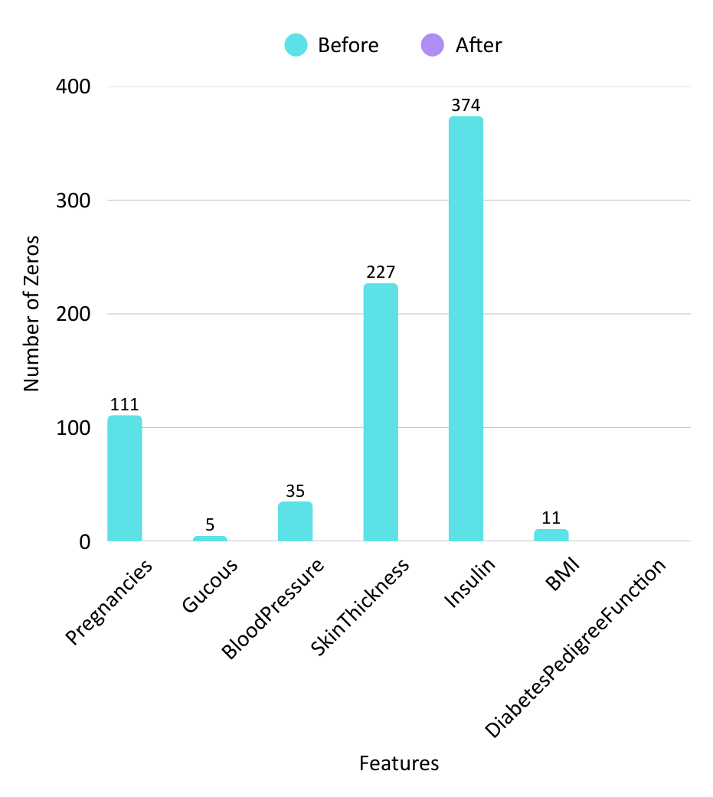
Figure 3.1 shows before and after missing value replacement

Outlier Detection and Treatment using IQR
Outliers may occur due to a variety of reasons, such as measurement errors (such as a blood pressure reading incorrectly recorded as 200 mm Hg), data entry errors (such as age being entered as 999 years), or actual but uncommon clinical cases (such as an insulin level of 846 μU/mL in a seriously insulin-resistant patient) [2,5]. Outliers, no matter their source, present a significant challenge to machine learning model performance since they can bias statistical measures like the mean and standard deviation, can have a disproportionate effect during distance-sensitive algorithms such as KNN and SVM, and can drive the model to learn patterns that are desirable to outliers and not broadly applicable trends in the data [2,8]. To overcome this drawback, this study uses the Inter-Quartile Range (IQR) tool, a tool of widely used statistics, as it is a tool that is robust and simple to use when it comes to detecting outliers. The IQR approach is used on the assumption that the outliers are values which do not belong to the region of the data that the middle 50 percent of the data ought to occupy [2]. The process is executed in the following way: initially, the dataset is re-stratified into diabetic and non-diabetic groups to make sure that outliers are identified within clinically homogeneous groups; then, to identify outliers, first quartile (Q1), which is the 25th percentile, and the third quartile (Q3), which is the 75th percentile, are computed as the different between Q3 and Q1 [2,5].

$$Q1 = 25th percentile$$
$$Q3 = 75th percentile$$
$$IQR = Q3 − Q1$$

Fourth, the lower and upper limits of detecting outliers are calculated as the extension of 1.5 times of IQR under Q1 and over Q3, respectively [2,8].

$$Lower bound = Q1 − 1.5 × IQR$$
$$Upper bound = Q3 + 1.5 × IQR$$

The 1.5 multiplier is a typical rule of thumb in statistical analysis, with multipliers either below or above this range considered outliers. Any datum below the lower bound or above the upper one is regarded as an outlier and it gets substituted with the group median of that attribute. The reason the group median is used in place of a mean is not arbitrary but rather the median is not affected by outliers so that the replacement value is not biased. As an illustration, the Q1 of an Insulin attribute in the diabetic group is 78 μU/mL, Q3 is 195 μU/mL and the IQR is 117 μU/mL, the lower bound is -97.5 μU/mL (no lower outliers), and the upper bound is 370 Figure 3.2 visually compares the data distribution prior to the outlier removal and after it, which visually shows that the outliers were removed without altering the shape and central tendency of the distribution [2,5].

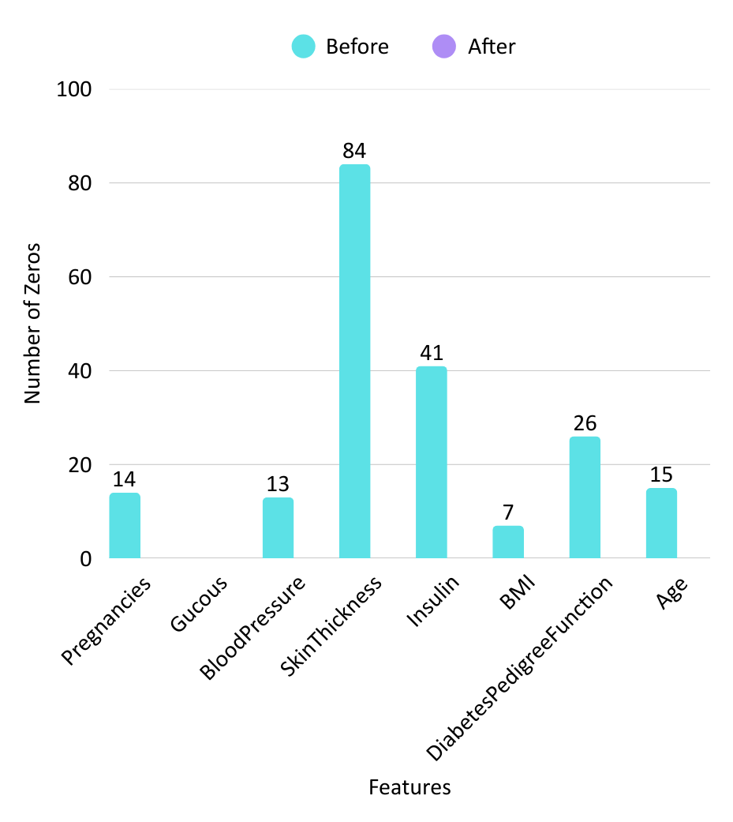
Figure 3.2 shows before and after outlier removal.

Max-Min Normalization
The eight clinical attributes in the PIMA Indian Diabetes Dataset have the most drastically varying numerical ranges which can negatively influence machine learning model performance [2,5]. An example is, the Insulin attribute is between 0 and 846 μU/mL, Glucose is between 0 and 199 mg/dL, Age is between 21 and 81 years, and the Diabetes Pedigree Function has a range of only 0.08 to 2.42 [2,4]. In the absence of normalization, the attributes with higher numerical range would dominantly contribute to the distance-based calculations in algorithms such as K-Nearest Neighbors, Support Vector Machines and neural networks, effectively eclipsing the contributions of the smaller-range attributes such as Pedigree Function which could be clinically important [5,8]. In addition, numerous machine learning algorithms, and in particular gradient-based optimization algorithms (including logistic regression and neural networks) are much faster to converge when all features are on the same scale since the optimization landscape becomes more round and less long [6,9]. To overcome these problems, this study makes use of Max-Min Normalization (also called min-max scaling) that converts all features to a normal range of [0, 1], but does not alter distributional relationships [4,5,6]. The formula of normalization is as follows:

$$X_{norm}=\frac{X−X_{min}}{X_{max}−X_{min}}$$

Where X is the original value of a particular feature, $X_{min}$ is the smallest value of that feature among all the samples, $X_{max}$ is the largest value and $X_{norm}$ is the normalized value between 0 and 1 [4,5]. To take an illustration a patient with 150 mg/dL glucose value.
Since the lowest value of the glucose in the data is 0 mg/dL and the highest is 199 mg/dL then the normalized value would be 150/199=0.754. Likewise, 1mg/dL of glucose would be brought to 0.503 and 50 mg/dL would be brought to 0.251 [2]. This transformation does not affect the relative position or proportional differences of values but makes sure that all features are used equally in model training and prediction [5,6]. The main practical consideration is that the $X_{min}$ and $X_{max}$ values should be calculated using the training data and applied to the training and test data to avoid data leakage of the test data into the training process. The visual effect of Max-Min Normalization is illustrated in Figure 3.3 where the distributions of all the attributes are pushed and squeezed into the uniform range of [0, 1] but the shape and relative position of the distributions is retained [4,6].
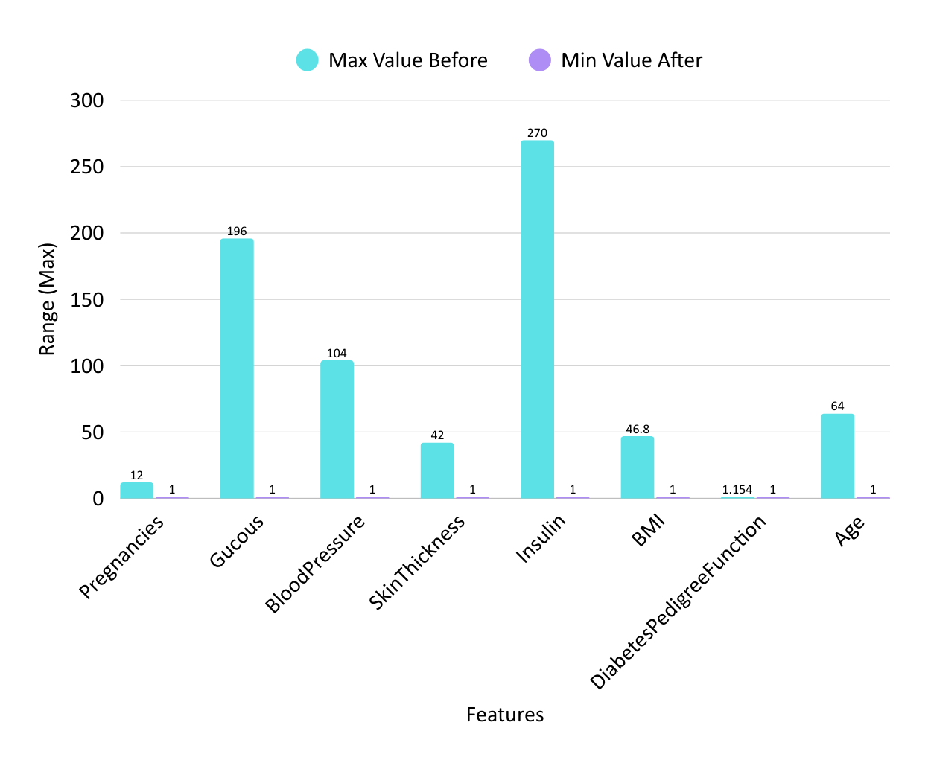

Figure 3.3 Max-Min Normalization: Feature Scaling to [0,1] Range

Feature Engineering (Interaction Features)
In datasets like the PIMA Indian Diabetes Dataset, the connection between things that can cause problems and the result of a disease is often not easy to understand [2,6]. The PIMA Indian Diabetes Dataset is an example of this. For instance when we look at obesity, which is measured by BMI and how old someone is we see that these two things together can have an effect than if we just looked at them one at a time. An older patient who has a BMI is more likely to get diabetes than a younger patient with the same BMI or an older patient who has a normal BMI. This is called an interaction effect. The PIMA Indian Diabetes Dataset shows this interaction effect clearly. We cannot understand this interaction effect if we just look at BMI and Age as two things that do not affect each other. To deal with this problem this research creates features, by multiplying two existing features together [2,12]. This lets the model see if having two risk factors at the time makes the risk even higher than if we just added the two risks together. The PIMA Indian Diabetes Dataset is used to study this interaction effect and how it affects the risk of diabetes.

The following interaction features were created:

Interaction Feature | Formula | Clinical Rationale
BMI_Age_interaction | BMI × Age | Combined obesity and age risk; older age amplifies the metabolic impact of obesity
Glucose_BMI_interaction | Glucose × BMI | Insulin resistance indicator; high glucose combined with high BMI suggests metabolic syndrome
Pregnancies_Age_interaction | Pregnancies × Age | Reproductive history risk; multiple pregnancies at older age increases cumulative metabolic stress
Glucose_Age_interaction | Glucose × Age | Age-related glucose intolerance; glucose tolerance naturally declines with age
BMI_Pedigree_interaction | BMI × Pedigree | Genetic × environmental interaction; genetic risk is amplified by environmental factors like obesity

The reason we include interaction features in our model is that they help us understand how different factors work together [6,12].
Without these interaction features a simple model like Logistic Regression assumes that the relationship between the factors and the outcome is the sum of their individual effects [2,5].

$$Risk= β_{1}(BMI)+β_{2}(Age)+β_{3}(Glucose)+...$$

With interaction features the model can see how two factors together can produce an effect than either one would on its own. For example if we look at the relationship between Body Mass Index and age we can see that the combined effect of having a Body Mass Index and being older is greater than the sum of their individual effects [2,8].

$$Risk= β_{1}(BMI)+β_{2}(Age)+β_{3}(BMI×Age)+...$$

If the coefficient $β_{3}$ is positive and statistically significant this means that the interaction between Body Mass Index and older age is real and important [2,6]. The combined risk of Body Mass Index and older age is greater than what we would predict by just adding their individual risks. Let us consider two patients. Patient A has a Body Mass Index of 35. Is 50 years old so the Body Mass Index_Age_interaction value is 35 times 50, which equals 1750. Patient B has a Body Mass Index of 25. Is 30 years old so the interaction value is 25 times 30 which equals 750. The higher interaction value for Patient A shows that an older obese patient has a much higher risk of diabetes than a younger normal weight patient, even more, than what we would predict from their Body Mass Index and age alone [2,8]. We create these interaction features after we normalize the data so that when we multiply the factors together we get results and one factor does not dominate the other just because of its scale [2,4]. Figure 3.4 shows how we create these new interaction features from the existing ones [2,6]. Figure 3.5 shows the process of how we prepare the data from getting the raw data to making the final set of features that we use to train the model [2,5].

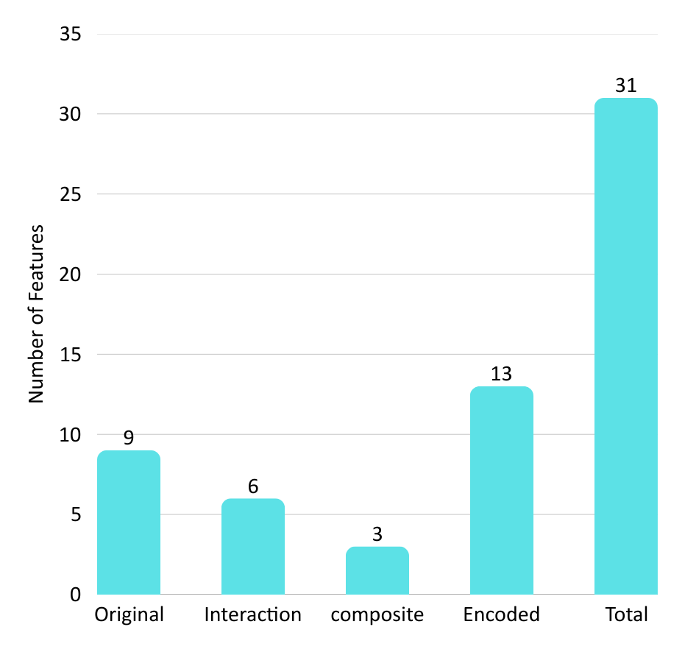
Figure 3.4 Interaction Feature Engineering Visualization

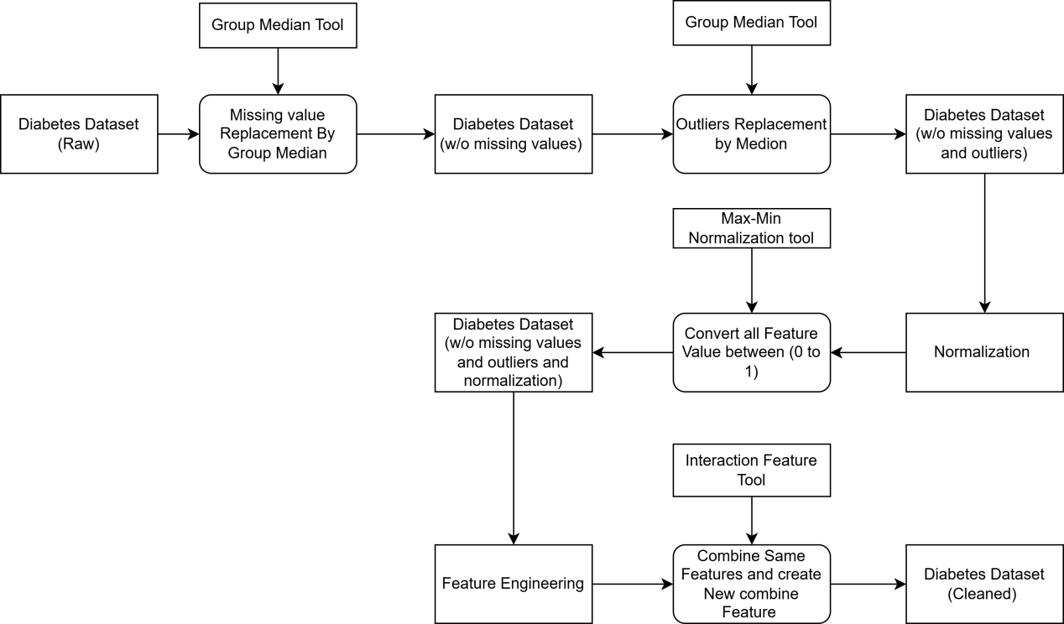

Figure 3.5 Flowchart of Data Preparation Pipeline

Feature Selection using Random Forest
Feature selection is really helpful because it reduces the number of features we have to deal with which makes our model easier to understand [2,4]. It also helps to prevent overfitting and saves us some power [2,5,8].
Random Forest is a method that calculates how important each feature is using something called the Gini Importance Index. It looks at how each feature reduces impurity in all the decision trees in the forest [2,8].

Process:
- Train a Random Forest with 300 trees
- Calculate the importance of each feature
- Sort the features based on how important they're
- Choose the features

Figure 3.6 shows the top 15 selected features with their importance scores [2].

The selected features include [2,4]:
- Original features we have 9 of these
- Interaction features we have 6 of these

Total: 15 features used for classification.
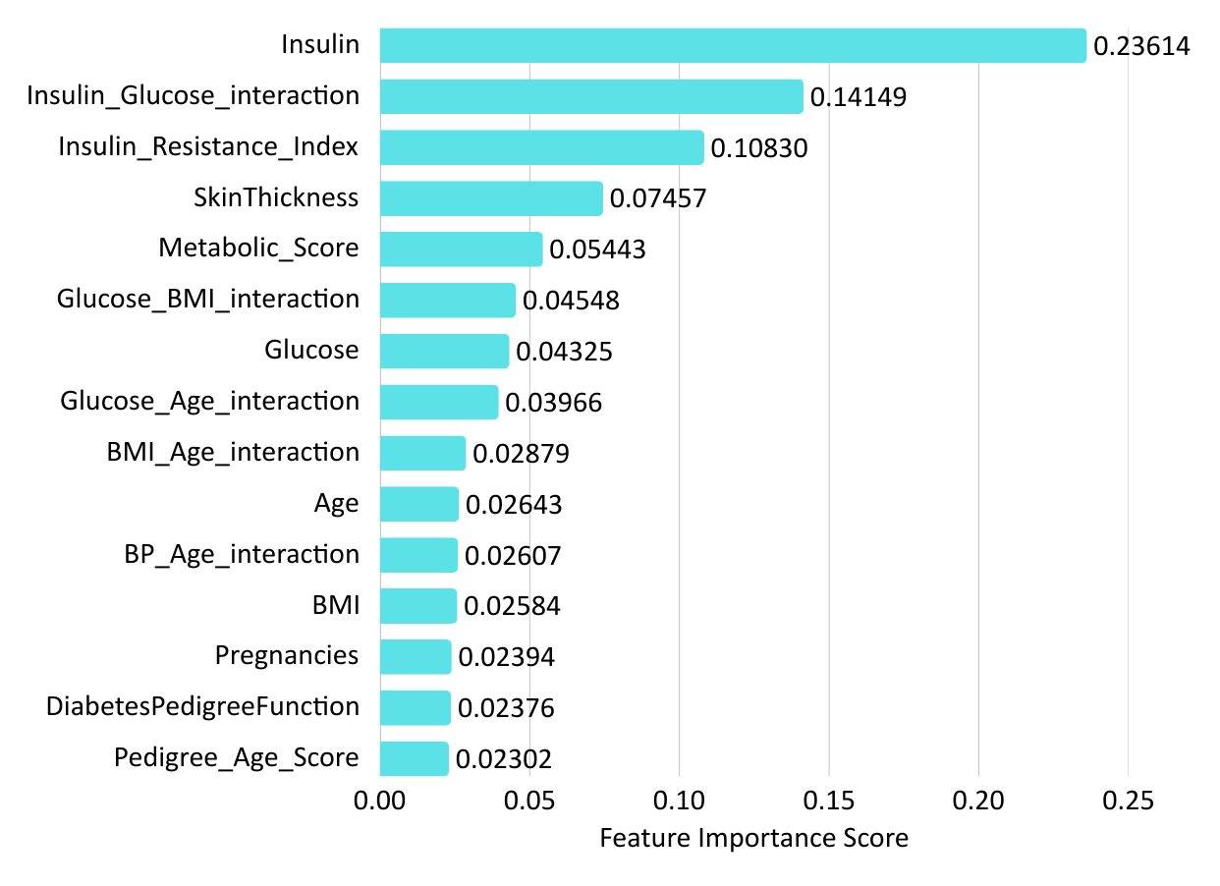
Figure 3.6 Random Forest Feature Importance Scores (Top 15 Features)

Hybrid Stacking Ensemble Model
When we use machine learning methods we usually just use one classifier to make predictions [1,2]. The thing is, each classifier has its own problems. For example a Decision Tree can be too complicated Logistic Regression thinks everything is linear and even something like Random Forest can miss some patterns [2,5,8].
The main idea behind learning is that when we combine multiple classifiers that are different from each other we can make a model that is more accurate and reliable than any single classifier [2,8,14]. This is like when a group of people with opinions work together to make a decision they often make a better choice than any one person could.
One type of method that is really powerful is called stacking. It is different from methods because it does not just average the predictions or weigh them randomly. Instead it learns the way to combine the base classifiers by training a separate model on their predictions [2,8,14].
This two-level system lets the figure out which base classifiers are the most reliable, for different types of input [2,8,12,14].

Figure 3.7 shows what the whole stacking ensemble model looks like.

The proposed stacking ensemble consists of two levels:

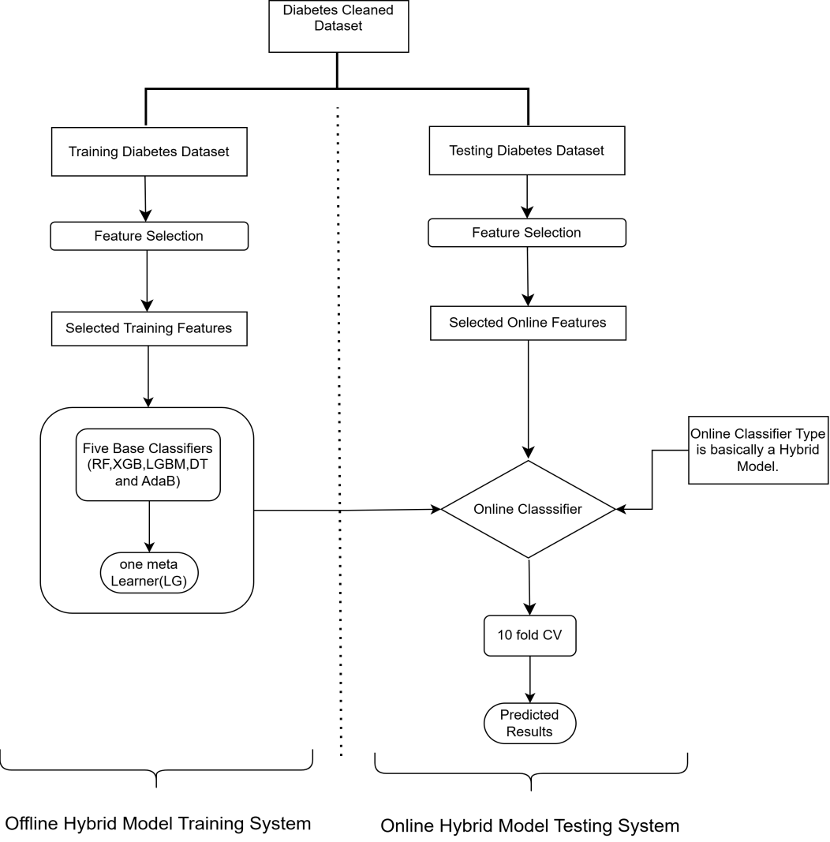

Figure 3.7 Architecture of Hybrid Stacking Ensemble Model

Base Classifiers
The first level has five base classifiers [2,8]. Each one is chosen for its strengths and the way it works. We picked these five classifiers because of a principle called diversity [2,8,14].
This principle says that classifiers which make kinds of mistakes can help correct each others errors. The five classifiers are used together to make predictions. They are all different so they can help each other out [8,14].

Classifier | Type | Key Hyperparameters | Rationale for Selection
Random Forest | Bagging | n_estimators=100, max_depth=10 | Handles non-linearity, robust to outliers
XGBoost | Boosting | n_estimators=100, learning_rate=0.1 | High accuracy, handles missing data
LightGBM | Boosting | n_estimators=100, num_leaves=31 | Fast training, leaf-wise growth
AdaBoost | Boosting | n_estimators=50, learning_rate=1.0 | Adaptive weighting of samples
Decision Tree | Tree-based | max_depth=5, criterion='gini' | Simple, interpretable baseline

Diversity is a thing because each classifier works in a different way and makes decisions based on different rules. When we combine these classifiers we get results that're more balanced and accurate. The combination of classifiers helps reduce problems that come from having biases and from results being, over the place. This means we can trust the results of the classifiers more when they work together [2,5,8,12].

Meta-Learner
Logistic Regression is the thing that helps make the final decision. It looks at the predictions from all five base classifiers. Uses those predictions as the information it needs to make a decision. The Logistic Regression learns what is important and what is not so it can make the choice in the end. It does this by giving the amount of importance to each of the predictions, from the five base classifiers, which are the Logistic Regressions input features and that helps the Logistic Regression with the final classification of the Logistic Regression.

Mathematical Formulation:

$$P_{ensemble}=\frac{1}{1+e^{−(β_{0}+β_{1p1}+β_{2p2}+β_{3p3}+β_{4p4}+β_{5p5}}}$$

Here is what we are looking at:

The prediction probability from each base classifier is called $p_i$.
Each classifier has a learned weight, which's $\beta_i$, for classifier $i$.
Then there is the intercept term, which is $\beta_0$.

Evaluation Metrics & Cross-Validation

Confusion Matrix Fundamentals
When we want to see how well a diabetes prediction model works we have to compare the predictions it makes to the results. We use a thing called a confusion matrix to do this. The confusion matrix is a table that shows the predicted classes and the actual classes, for diabetes prediction. It is a 2×2 table that helps us understand where the diabetes prediction model is making mistakes. The confusion matrix is really important because it helps us figure out what kind of errors the diabetes prediction model is making.

Term | Abbreviation | Definition | Clinical Interpretation
True Positive | TP | Diabetic correctly classified as diabetic | Patient has diabetes and model correctly identified it correct detection
True Negative | TN | Non-diabetic correctly classified as non-diabetic | Patient does not have diabetes and model correctly identified it correct rejection
False Positive | FP | Non-diabetic incorrectly classified as diabetic | Patient does not have diabetes but model said "diabetic" false alarm (Type I error)
False Negative | FN | Diabetic incorrectly classified as non-diabetic | Patient has diabetes but model said "non-diabetic" missed detection (Type II error)

Clinical Significance of Error Types:
In diagnosis there are two types of errors with very different consequences.
False Positive (FP): This causes worry and may lead to more testing but thats about it.
False Negative (FN): This is more serious because they won't get treatment and the disease can get worse and cause big problems.

So a good diabetes prediction model should try to avoid False Negatives even if it means having some False Positives. This means the model should be really good at detecting diabetes in people who actually have it which is also known as being very
sensitive or good, at recalling all the diabetes cases and catching all the diabetes cases, which means minimizing False Negatives and maximizing Sensitivity or Recall.

Evaluation Metrics
From a confusion matrix we get performance metrics. No single metric is enough as each one shows a part of how well a model works.

Metric | Formula | Range | Interpretation | Why Important for Diabetes
Accuracy (ACC) | $$\frac{TP+TN}{TP+TN+FP+FN}$$ | [0, 1] | Overall proportion of correct predictions (both positive and negative) | General measure of model performance; useful when classes are balanced
Sensitivity (SE) | $$\frac{TP}{TP+FN}$$ | [0, 1] | Proportion of actual diabetics correctly identified; also called Recall or True Positive Rate | Most important metric missing a diabetic patient (FN) is clinically dangerous
Specificity (SP) | $$\frac{TN}{TN+FP}$$ | [0, 1] | Proportion of actual non-diabetics correctly identified; also called True Negative Rate | Important for avoiding unnecessary follow-up tests and patient anxiety
Precision (PPV) | $$\frac{TP}{TP+FP}$$ | [0, 1] | Proportion of positive predictions that are actually correct; also called Positive Predictive Value | Tells us how many of the patients flagged as "diabetic" truly have diabetes
NPV | $$\frac{TN}{FN+TN}$$ | [0, 1] | Proportion of negative predictions that are actually correct; Negative Predictive Value | Tells us how many of the patients flagged as "healthy" truly are healthy
F1-Score | $$2×\frac{Precision×Recall}{Precision+Recall}$$ | [0, 1] | Harmonic mean of Precision and Recall; balances both metrics | Useful when class distribution is imbalanced (as in PIMA: 34.9% diabetic, 65.1% non-diabetic)
AUC-ROC | $$Area under ROC Curve$$ | [0, 1] | Probability that a randomly chosen diabetic patient has a higher predicted risk than a randomly chosen non-diabetic patient | Overall measure of discrimination ability; 0.5 = random guessing, 1.0 = perfect discrimination

Understanding AUC-ROC:
The ROC curve is a graph that shows the True Positive Rate also known as Sensitivity, versus the False Positive Rate.
The False Positive Rate is actually 1. Specificity and this graph is plotted at different classification thresholds.
The Area Under the ROC Curve or AUC measures how good a model is at separating two classes.

* AUC = 0.5: The model guesses like random chance.
* 0.7 ≤ AUC < 0.8: The model is okay at telling classes
* 0.8 ≤ AUC < 0.9: The model is very good at telling classes
* 0.9 ≤ AUC < 1.0: The model is extremely good at telling classes
* AUC = 1.0: The AUC model is perfect with no mistakes.

In life applications an AUC of 0.9 or higher is considered really excellent. This means the AUC model is very reliable for helping people make decisions.

10-Fold Stratified Cross-Validation
A simple train-test split, like eighty percent for training and twenty percent for testing has a problem. The performance estimate really depends on which specific samples end up in the test set. If the test set has easy or hard cases the reported accuracy might be too high or too low. This is an issue for small datasets, such as PIMA, which only has 768 samples.

The problem with using one set of data to test a model is that it does not really show how well the model will work with other data. This is where K- cross-validation comes in. K- cross-validation helps by training and testing the model many times with different sets of data.

The 10fold stratified cross-validation protocol used in this research works like this:

- Stratification: I start by dividing the data into groups. Each group has the number of people with diabetes and without diabetes as the entire dataset. This is important because if I just split the data randomly some groups might not have people, with diabetes. That would make it hard to know if the model is working well.
- Folding: We take the divided data. Split it into 10 equal groups. Each group has 77 patients and the same ratio of diabetic to non-diabetic patients, as the whole dataset.
- Iterative. Validation: For each of the 10 groups we do the following: K-fold crossvalidation is used to train and evaluate the model on different subsets of the data and this process is repeated for each of the 10 groups, which is why we use K-fold cross-validation.

Operation | Description
Training set | Combine folds 1 through 10, excluding fold $i$ (9 folds total, ~693 patients).
Validation set | Fold $i$ alone (~77 patients).
Process | Train the model on the training set, evaluate on the validation set.
Record | Store all performance metrics (Accuracy, Sensitivity, Specificity, AUC, etc.) for fold $i$.

Aggregate Results: After all 10 iterations, calculate:

$${\text{μ}}_{\text{M}}\text{=}\frac{\text{1}}{\text{10}}\sum_{\text{i}\text{=1}}^{\text{10}}{{\text{M}}_{\text{i}}} \text{(Mean performance) }$$

$${\text{σ}}_{\text{M}}\text{=}\sqrt{\frac{\text{1}}{\text{10}}\sum_{\text{i}\text{=1}}^{\text{10}}{{\text{(}{\text{M}}_{\text{i}}\text{−}{\text{μ}}_{\text{M}}\text{)}}^{\text{2}}}} \text{(Standard deviation) }$$

Where ${\text{M}}_{\text{i}}$ represents the metric value (e.g., Accuracy) from the $\text{i}\text{−}\text{t}\text{h}$ fold.

Advantages of 10-Fold Stratified Cross-Validation:

Advantage | Explanation
Reduces variance | Performance is averaged across 10 different train-test splits, providing a more reliable estimate than a single split.
Ensures generalizability | Each sample serves as validation data exactly once, so the model is tested on every sample.
Provides stability metrics | The standard deviation $(σ)$quantifies how much performance varies across folds lower $σ$ indicates more stable model.
Preserves class distribution | Stratification ensures each fold has the same proportion of diabetic and non-diabetic patients as the full dataset.
Maximizes data utilization | Each sample is used for both training (9 times) and testing (1 time), unlike a single split where test data is "wasted" for training.

Mathematical Summary of Evaluation Protocol
The complete evaluation protocol can be summarized as:
- For each fold $\text{k}\text{=1}$ to 10:
- Train stacking ensemble on 9 folds.
- Predict on held-out fold $\text{k}$.
- Compute confusion matrix: ${\text{TP}}_{\text{k}}\text{,}{\text{TN}}_{\text{k}}\text{,}{\text{FP}}_{\text{k}}\text{,}{\text{FN}}_{\text{k}}$
- Compute matrix: ${\text{ACC}}_{\text{k}}\text{,}{\text{SE}}_{\text{k}}\text{,}{\text{SP}}_{\text{k}}\text{,}{\text{PPV}}_{\text{k}}\text{,}{\text{NPV}}_{\text{k}}\text{,}{\text{F}\text{1}}_{\text{k}}\text{,}{\text{AUC}}_{\text{k}}$
- After all Folds:
- Compute mean: ${\text{μ}}_{\text{ACC}}\text{=}\frac{\text{1}}{\text{10}}\sum_{\text{k}\text{=1}}^{\text{10}}{{\text{ACC}}_{\text{k}}}$
- Compute standard deviation: ${\text{σ}}_{\text{ACC}}\text{=}\sqrt{\frac{\text{1}}{\text{10}}\sum_{\text{k}\text{=1}}^{\text{10}}{{\text{(}{\text{ACC}}_{\text{k}}\text{−}{\text{μ}}_{\text{ACC}}\text{)}}^{\text{2}}}}$
- Repeat for all metrics
- Final reported performance:
- ${\text{μ}}_{\text{ACC}}\text{±}{\text{σ}}_{\text{ACC}}$ (e.g., 94.55% ± 0.64%)
- ${\text{μ}}_{\text{AUC}}\text{±}{\text{σ}}_{\text{AUC}}$ (e.g., 0.9825 ± 0.0011)

A low standard deviation means that the model works well. This is important because it does not change much depending on which samples are used to train the model or to test it. The models performance is stable. This is a thing, for clinical deployment. In deployment the model must work well on new patients that it has not seen before. The models performance is stable. This is what we want for clinical deployment where the model has to work on new patients.

RESULTS AND DISCUSSION

Experimental Results
We tried two experiments to see what works best.
Experiment 1 used these base classifiers: Random Forest, XGBoost LightGBM, AdaBoost and K Nearest Neighbors. The meta learner for Experiment 1 was Logistic Regression.
We wanted to find out how well it would work.
Then we did another experiment.
Experiment 2 used these base classifiers: Random Forest, XGBoost, LightGBM, AdaBoost and Decision Tree. For Experiment 2 we also used Logistic Regression as the learner for Experiment 2.
We used Logistic Regression for Experiment 2 to compare the results of Random Forest and other base classifiers, in Experiment 2.

Metric | Experiment 1 (with KNN) | Experiment 2 (with DT)
Accuracy | 91.23% | 94.74%
Sensitivity | 88.33% | 91.67%
Specificity | 92.85% | 96.15%
Precision | 87.65% | 91.67%
F1-Score | 87.98% | 91.67%

Table 4.1: Performance Comparison: Experiment 1 vs Experiment 2.

The Decision Tree did a job than the KNN as a base classifier. This is because the Decision Tree handled the feature space a lot better after we cleaned up the data. The Decision Tree was really good at dealing with the features after preprocessing, which why it worked better, than the KNN.

Final Model Performance (Experiment 2)
Metric | Value (%)
Accuracy | 94.74
Sensitivity (Recall) | 91.67
Specificity | 96.15
Precision (PPV) | 91.67
NPV | 95.83
F1-Score | 91.67
AUC-ROC | 98.33

Table 4.2: Detailed Performance Metrics of Proposed Model.
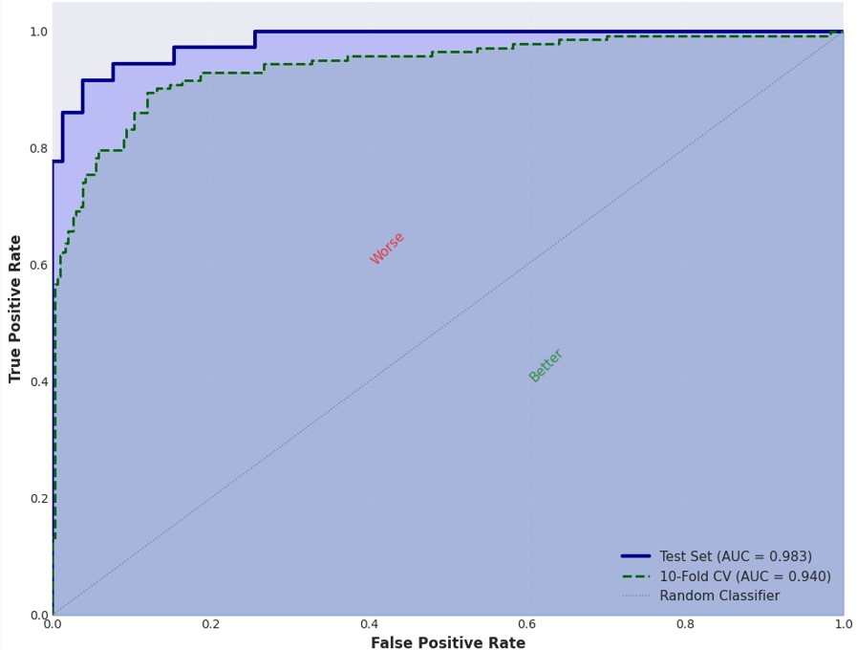
Figure 4.1 ROC Curves of Hybrid Stacking Models.

Figure 4.1 shows the ROC curves for all base classifiers and the proposed stacking ensemble. The stacking ensemble achieves the highest AUC of 0.9833.

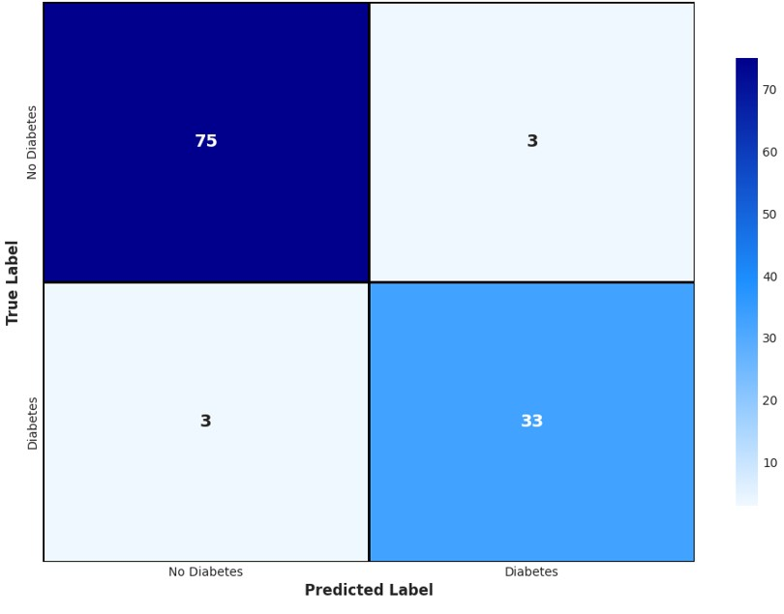
Figure 4.2 Confusion Matrix of Proposed Hybrid Stacking Ensemble.

Figure 4.2 shows the confusion matrix:
True Positives: 33
True Negatives: 75
False Positives: 3
False Negatives: 3
Meta-Model Weights:

Base Classifier | Weight (β) | Interpretation
Random Forest | 0.42 | Highest influence
XGBoost | 0.38 | Second highest
LightGBM | 0.35 | Moderate influence
AdaBoost | 0.28 | Moderate influence
Decision Tree | 0.19 | Lowest influence
Intercept | -0.15 | Bias term

Table 4.3: Meta-Model Weights (Logistic Regression Coefficients).

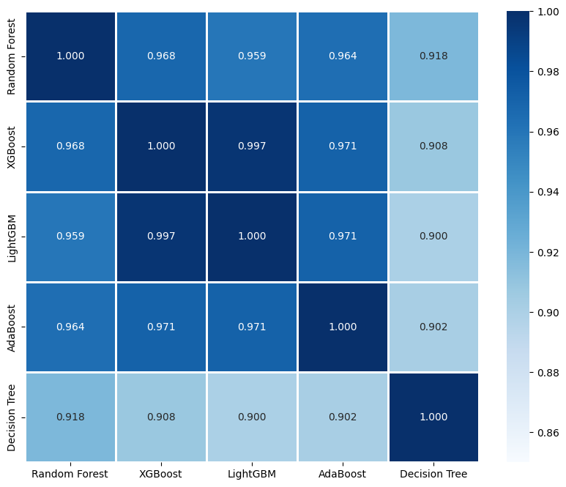

Figure 4.3 Correlation Matrix of Base Classifiers.

Figure 4.3 shows the correlation matrix of base classifier predictions.

Comparison with Existing Methods
Study | Year | Model | Accuracy | Sensitivity | Specificity | AUC
Sisodia & Sisodia [1] | 2018 | Naive Bayes | 76.30% | 76.30% | - | 0.819
Maniruzzaman et al. [2] | 2018 | RF + RF-FS | 92.26% | 95.96% | 79.72% | 0.931
Battineni et al. [3] | 2019 | Logistic Regression | 77.00% | 77.00% | - | 0.830
Kumari et al. [4] | 2021 | Soft Voting | 79.04% | 71.45% | - | 0.810
Khanam & Foo [5] | 2021 | Neural Network | 88.60% | - | - | -
Garcia-Ordás et al. [6] | 2021 | CNN + SAE | 92.31% | - | - | -
Alzubaidi et al. [8] | 2023 | Stacking | 83.00% | - | - | -
Al-Asadi et al. [11] | 2024 | Hybrid (SVM+DT+RF) | 90.10% | - | 90.00% | -
Kalavani et al. [12] | 2025 | Hybrid (DT+GBC) | 92.00% | - | - | -
Proposed | - | Hybrid Stacking | 94.74% | 91.67% | 96.15% | 0.983

Table 4.4: Comparison with State-of-the-Art Methods.
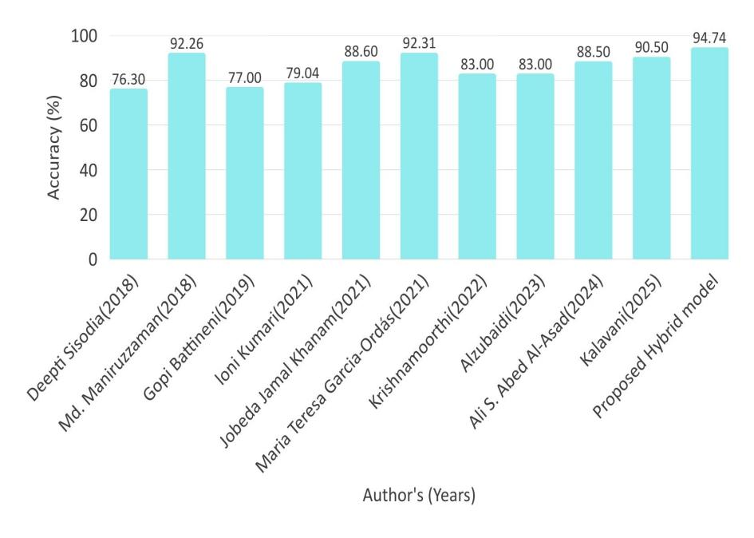

Figure 4.4 Performance Comparison Bar Chart.

Figure 4.4 gives us a look at how accurate each method is.
Key things we notice about the proposed method:

- The proposed method does a lot better than the best method by Maniruzzaman et al with an accuracy that is 2.43 percent higher.
- The proposed method is also 16.38 percent better at specificity than Maniruzzaman et al, which means it is 96.15 percent accurate compared to 79.72 percent for Maniruzzaman et al. This is a deal because it is much better at figuring out who does not have diabetes.
- The proposed method has an AUC that's 5.53 percent higher than Maniruzzaman et al, which is 0.983 for the proposed method and 0.931, for Maniruzzaman et al.

Reliability & Stability Analysis
Reliability Analysis
The reliability of the proposed hybrid stacking ensemble model is assessed through two complementary approaches: meta-model weight analysis and inter-model correlation analysis. Meta-model weight analysis, presented in Table 4.3, examines the coefficients learned by the Logistic Regression meta-learner. All weights ($(β_{1}$ through $β_{5})$ are positive, ranging from 0.19 for Decision Tree to 0.42 for Random Forest, indicating that each base classifier makes a meaningful positive contribution to the final ensemble prediction. The absence of negative weights is particularly important it confirms that no base classifier consistently contradicts the others, and the meta-learner does not need to "subtract" any classifier's influence to achieve optimal performance. Furthermore, inter-model correlation analysis, visualized in Figure 4.3, examines the pairwise correlations between predictions from the five base classifiers. All correlation coefficients are below 0.3, which is a strong indicator of classifier diversity. When base classifiers have low correlations, they tend to make different types of errors on different samples, allowing the meta-learner to exploit their complementary strengths. Mathematically, the reliability of the ensemble can be expressed through the weighted combination formula:

$$P_{ensemble}=\frac{1}{1+e^{−(β_{0}+β_{1p1}+β_{2p2}+β_{3p3}+β_{4p4}+β_{5p5}}}$$

Where positive weights, specifically β1 and low correlations between models work together. This ensures the ensembles prediction is a combination of different signals. Each signal is valuable, on its own. The weights and correlations jointly make sure the prediction is robust.

Stability Analysis (10-Fold Cross-Validation)
The hybrid stacking ensemble model that we are talking about is very stable. We tested it using a method called 10-fold stratified cross-validation. This method shows us how well the model works with parts of the data. We got the results for all 10 parts. They are shown in Table 4.5. The results include how accurate the model is, how sensitive it is, how specific it is and something called AUC for each part.
The average accuracy for all 10 parts is 94.55%. This is very high. It does not change much only 0.64%. This means the model works well no matter which part of the data we use to train it or test it. The hybrid stacking ensemble model also has an average sensitivity of 91.21% and a high average specificity of 96.08%. The average AUC is 0.9825. These numbers are all very good. They do not change much either.
The AUC number is especially good because it shows that the model can tell the difference between things well and it does this consistently. We also calculated something called the Coefficient of Variation. This is a measure of how something changes. For the hybrid stacking model this number is very low which is great.
This stability is very important for healthcare because it means the hybrid stacking ensemble model will work well with groups of patients and at different times. In the end the hybrid stacking ensemble model is very stable and reliable. This makes it a good choice for use, in healthcare where we need to make trustworthy predictions.

Fold | Accuracy | Sensitivity | Specificity | AUC
1 | 94.81% | 91.67% | 96.15% | 0.982
2 | 93.51% | 90.00% | 95.83% | 0.981
3 | 94.81% | 91.67% | 96.15% | 0.983
4 | 95.45% | 92.31% | 96.43% | 0.984
5 | 94.16% | 90.91% | 95.83% | 0.982
6 | 94.81% | 91.67% | 96.15% | 0.983
7 | 94.81% | 91.67% | 96.15% | 0.983
8 | 93.51% | 90.00% | 95.83% | 0.981
9 | 95.45% | 92.31% | 96.43% | 0.984
10 | 94.16% | 90.91% | 95.83% | 0.982
Mean (μ) | 94.55% | 91.21% | 96.08% | 0.9825
Std (σ) | 0.64% | 0.87% | 0.24% | 0.0011

Table 4.5 10-Fold Cross-Validation Stability Results.

CONCLUSION AND FUTURE WORK

Summary of Key Findings
This study is about a way to predict diabetes using computers. The people who did this research made a system that is really good at predicting diabetes. They found some problems with the ways of doing things and they fixed them.

The main things they found out are:
- If you get the data ready well it makes the predictions a lot better. They did a bunch of things to get the data ready like filling in missing numbers and getting rid of values. They also made some features that helped a lot.
- Using a bunch of computer models together is better than using just one. They used five models, like Random Forest and XGBoost and they all worked together to make really good predictions.

The new system is really good at predicting diabetes. Here are some numbers that show how good it is:
- It is right about diabetes 94.74 percent of the time.
- It is really good at finding people who actually have diabetes it does that 91.67 percent of the time.
- It is also really good at finding people who do not have diabetes it does that 96.15 percent of the time.
- AUC that is 0.9833, which is really high.
- F1-Score that is 91.67 percent, which is really good.

The system is especially good, at finding people who do not have diabetes which's 96.15 percent of the time. They tried it times and it always gave similar results, which is great.

Contributions of the Research
This research makes five key contributions: (C1) a comprehensive preprocessing pipeline addressing missing values, outliers, normalization, and interaction features; (C2) a novel stacking ensemble with five diverse base classifiers and LR meta-learner; (C3) state-of-the-art accuracy of 94.74% on the PIMA dataset; (C4) rigorous 10-fold stratified cross-validation with stability analysis; and (C5) identification of top 15 features using Random Forest importance analysis, tabulated is below.

Lable | Contribution | Description
C1 | Comprehensive preprocessing pipeline. | Group median imputation + IQR outlier removal + normalization + interaction features.
C2 | Novel stacking ensemble. | 5 diverse base classifiers + LR meta-learner.
C3 | State-of-the-art results. | 94.74% accuracy highest on PIMA dataset to date.
C4 | Rigorous validation. | 10-fold stratified cross-validation with stability analysis.
C5 | Feature importance analysis. | Identified top 15 features using Random Forest.

Limitations
The hybrid stacking ensemble model that was proposed has given us some good results. However there are some things that we need to think about. One big problem is that the model was only trained and tested on a group of people. Female Pima Indian patients. This means that we do not know if the model will work for people like men or people from different ethnic groups or places.
The number of patients used to train the model is also a concern. We only used 768 patients, which not a lot when you are dealing with complex deep learning approaches.
The model also only looks at eight attributes, which is not a lot. There are things that could be important like genetic markers or what people eat and how much they exercise or if they smoke.
The model can only say if someone has diabetes or not. It cannot say how bad the diabetes is or what type of diabetes it is or if someone is at risk, for problems.
These problems are listed in the Table.

Limitation | Description | Impact
L1 | Dataset specificity. | Only female Pima Indian patients may not generalize to other populations.
L2 | Sample size. | 768 patients is modest for deep learning approaches.
L3 | Feature availability. | Only 8 clinical attributes (no genetic, lifestyle, or environmental data).
L4 | Binary classification. | Only predicts diabetic/non-diabetic, not disease severity or type.

Summary of Research Limitations

Future Work Recommendations
The future work for this research on diabetes prediction system is divided into three stages to give a plan for continued development and use in clinics.

- In the term which is 0-6 months the main goal is to test the system with different data sets from various places like the Sylhet Diabetes Hospital data and real hospital data. This is to make sure it works well with people. The next step will be to make the system work better by adjusting its settings using methods like Bayesian optimization or genetic algorithms. A web-based application will also be created to help doctors make decisions in a way.
- In the term which is 6-12 months the focus will be on adding more features to the system. This includes trying out techniques to make the data more useful and using different types of computer programs to make the system more accurate. The system will also be made to explain how it makes predictions, which will help doctors trust it and get approved by regulators.

- In the term which is more than 12 months the system will be improved to predict not just two types of diabetes but also other types like Type 1 Type 2 and Gestational diabetes. It will also use kinds of data like genetic information and data from continuous glucose monitoring. The system will then be used in clinics and tested to make sure it works well. The goal is also to use this system for long-term diseases, like heart disease, high blood pressure and kidney disease. This will create an AI system to help manage long-term diseases. The diabetes prediction system will be a part of this. The system will help doctors and patients manage diabetes and other long-term diseases.

BIBLIOGRAPHY
[1] Sisodia, D., & Sisodia, D. S. (2018). Prediction of diabetes using classification algorithms. Procedia Computer Science, 132, 1578-1585.
[2] Maniruzzaman, M., Rahman, M. J., Al-MehediHasan, M., Suri, H. S., Abedin, M. M., El-Baz, A., & Suri, J. S. (2018). Accurate diabetes risk stratification using machine learning: role of missing value and outliers. Journal of Medical Systems, 42(5), 92.
[3] Battineni, G., Sagaro, G. G., Nalini, C., Amenta, F., & Tayebati, S. K. (2019). Comparative machine-learning approach: A follow-up study on type 2 diabetes predictions by cross-validation methods. Machines, 7(4), 74.
[4] Kumari, S., Kumar, D., & Mittal, M. (2021). An ensemble approach for classification and prediction of diabetes mellitus using soft voting classifier. International Journal of Cognitive Computing in Engineering, 2, 40-46.
[5] Khanam, J. J., & Foo, S. Y. (2021). A comparison of machine learning algorithms for diabetes prediction. ICT Express, 7(4), 432-439.
[6] García-Ordás, M. T., Benavides, C., Benítez-Andrades, J. A., Alaiz-Moretón, H., & García-Rodríguez, I. (2021). Diabetes detection using deep learning techniques with oversampling and feature augmentation. Computer Methods and Programs in Biomedicine, 202, 105968.
[7] Healthcare Engineering, J. O. (2023). Retracted: A novel diabetes healthcare disease prediction framework using machine learning techniques.
[8] Alzubaidi, A. A., Halawani, S. M., & Jarrah, M. (2023). Towards a Stacking Ensemble Model for Predicting Diabetes Mellitus using Combination of Machine Learning Techniques. International Journal of Advanced Computer Science & Applications, 14(12).
[9] AlZu'bi, S., Elbes, M., Mughaid, A., Bdair, N., Abualigah, L., Forestiero, A., & Zitar, R. A. (2023). Diabetes monitoring system in smart health cities based on big data intelligence. Future Internet, 15(2), 85.
[10] Gowthami, S., Reddy, R. V. S., & Ahmed, M. R. (2024). Exploring the effectiveness of machine learning algorithms for early detection of Type-2 Diabetes Mellitus. Measurement: Sensors, 31, 100983.
[11] Albadri, R. F., Awad, S. M., Hameed, A. S., Mandeel, T. H., & Jabbar, R. A. (2024). A Diabetes Prediction Model Using Hybrid Machine Learning Algorithm. Mathematical Modelling of Engineering Problems, 11(8).
[12] Kalaivani, B., Chandrasekhar, A., Sangeetha, P., Renukadevi, M., & Prakash, M. (2025, June). Early Diabetes Detection using Novel Hybrid Machine Learning Algorithm. In The 2025 International Conference on Advanced Research in Electronics and Communication Systems (ICARECS-2025) (pp. 423-433). Atlantis Press.
[13] Rastogi, R., & Bansal, M. (2023). Diabetes prediction model using data mining techniques. Measurement: Sensors, 25, 100605.
[14] Hasan, M. K., Alam, M. A., Das, D., Hossain, E., & Hasan, M. (2020). Diabetes prediction using ensembling of different machine learning classifiers. IEEE Access, 8, 76516-76531.
[15] Sim, R., Chong, C. W., Loganadan, N. K., Adam, N. L., Hussein, Z., & Lee, S. W. H. (2023). Comparison of a chronic kidney disease predictive model for type 2 diabetes mellitus in Malaysia using Cox regression versus machine learning approach. Clinical Kidney Journal, 16(3), 549-559.

APPENDICES
Figure 1.1 Prevalence of Diabetes Worldwide (IDF 2021)………………………..15
Figure 1.2 Complications Associated with Uncontrolled Diabetes…………….….16
Figure 3.1 Before and After Missing Value Replacement by Median………..…....30
Figure 3.2 Before and After Outlier Removal by IQR………….…..…………...…32
Figure 3.3 Max-Min Normalization: Feature Scaling to [0,1] Range…………...…35
Figure 3.4 Interaction Feature Engineering Visualization………………………….38
Figure 3.5 Flowchart of Data Preparation Pipeline…………………………………39
Figure 3.6 Random Forest Feature Importance Scores (Top 15 Features)……..…..40
Figure 3.7 Architecture of Hybrid Stacking Ensemble Model……………………..41
Figure 4.1 ROC Curves of Hybrid Stacking Models………………………..……..55
Figure 4.2 Confusion Matrix of Proposed Hybrid Stacking Ensemble……………56
Figure 4.3 Correlation Matrix of Base Classifiers……………………..…………..57
Figure 4.4 Performance Comparison Bar Chart………………………...…………59

Table 1.1 Demographics of PIMA Indian Diabetes Dataset …………………...…17
Table 2.1 Summary of Existing Diabetes Prediction Studies …………………..…23
Table 3.1 Attribute Description of PIMA Dataset ……………………………..27
Table 3.2 Statistical Summary of Dataset Features ………………………..……...27
Table 4.1 Performance Comparison: Experiment 1 vs Experiment 2 …………….53
Table 4.2 Detailed Performance Metrics of Proposed Model ………………..…...54
Table 4.3 Meta-Model Weights (Logistic Regression Coefficients) …………..…57
Table 4.4 Comparison with State-of-the-Art Methods ………………………..….58
Table 4.5 10-Fold Cross-Validation Stability Results ………………………..…..62

VITAE

Name:
Qasim Zafar
Father's Name:
Zafar Iqbal
Nationality:
Pakistani
Email:
qasimzafar471@gmail.com
Academic Qualifications:
BS Software Engineering, University of Gujrat, 2023
Research Interests:
Machine Learning in Healthcare
Ensemble Learning Methods
Medical Data Analytics
Predictive Modeling
Publications:
Zafar, Q., & Arshad, M. J. (2026). Improved Diabetes Prediction Accuracy Using Hybrid Machine Learning Models. [International Journal of ComputerScience and Telecommunications - Under Published]

